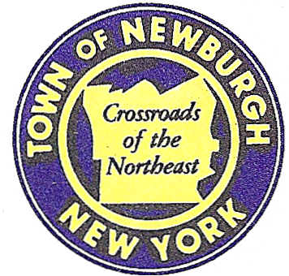

TOWN OF NEWBURGH
_______Crossroads of the Northeast __________________________
OLD TOWN HALL
308 GARDNERTOWN ROAD NEWBURGH, NEW YORK 12550

PLANNING BOARD
JOHN P. EWASUTYN, CHAIRMAN
TELEPHONE 845-564-7804
FAX 845-564-7802
E-MAIL: planningboard@townofnewburgh.org

PLANNING BOARD AGENDA

March 7, 2019

*PLEASE NOTE: The Planning Board Meeting will start at 7:00 P.M. and all Applicants/Representatives
are to be present at that time. The Meeting will be held in the Meeting Room of Town Hall,
located at 1496 Route 300, Newburgh NY.*

- 511 Gardnertown Road, LLC (19-05) INITIAL APPEARANCE
511 Gardnertown Road LOT LINE CHANGE
Section 60, Block 2, Lot 62
Zone: R-3
Rep: JMC
120 Bedford Road.
Armonk, NY 10504

- Lakeside Senior Housing (19-06) INITIAL APPEARANCE
Lakeside Road AMENDED SITE PLAN
Section 86, Block 1, Lot 39.22 & 39.23
Zone: IB
Rep: Mauri Architects, P.C./ Jay Diesing, RA
73 Mansion St.
Poughkeepsie, NY 12601

- 182 South Plank Road (19-08) INITIAL APPEARANCE
182 South Plank Road AMENDED SITE PLAN
Section 64, Block 2, Lot 8.21
Zone: B
Rep: Maser Consulting, P.A.
555 Hudson Valley Ave. Suite 101
New Windsor, NY 12553

*WORK SESSION*
Project Readiness Discussion scheduled for 5:30 p.m. in the Meeting Room of
Town Hall on Thursday, March 7th, 2019.*

- BJ’s Wholesale Club- Newburgh (19-07) INITIAL APPEARANCE
NYS Route 17K & Auto Park Place SITE PLAN
Section 97, Block 2, Lot 44,46.2 & 45
Zone: IB
Rep: Maser Consulting, P.A.
555 Hudson Valley Ave. Suite 101
New Windsor, NY 12553

PLANNING BOARD BUSINESS
WORK SESSION

*WORK SESSION*
Project Readiness Discussion scheduled for 5:30 p.m. in the Meeting Room of
Town Hall on Thursday, March 7th, 2019.*

